Brothen, Matt

Mini Project 1 – Java 1

Running Program:

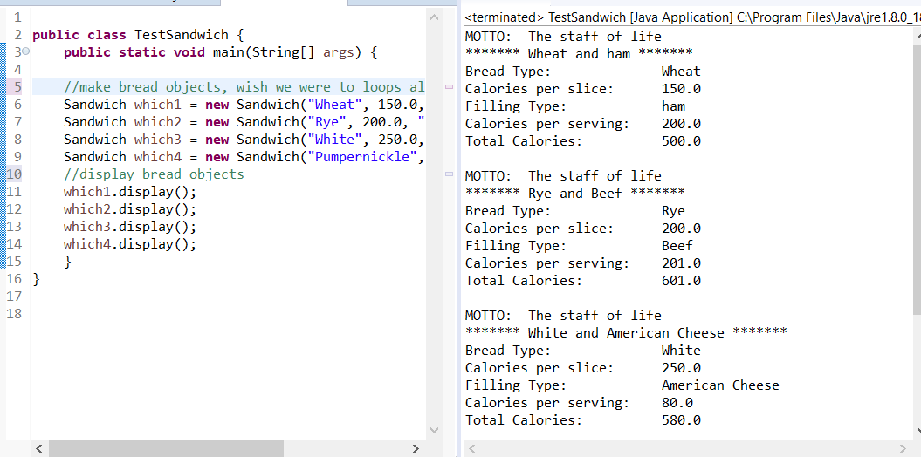

Bread.java

I added extra constructors for future calls

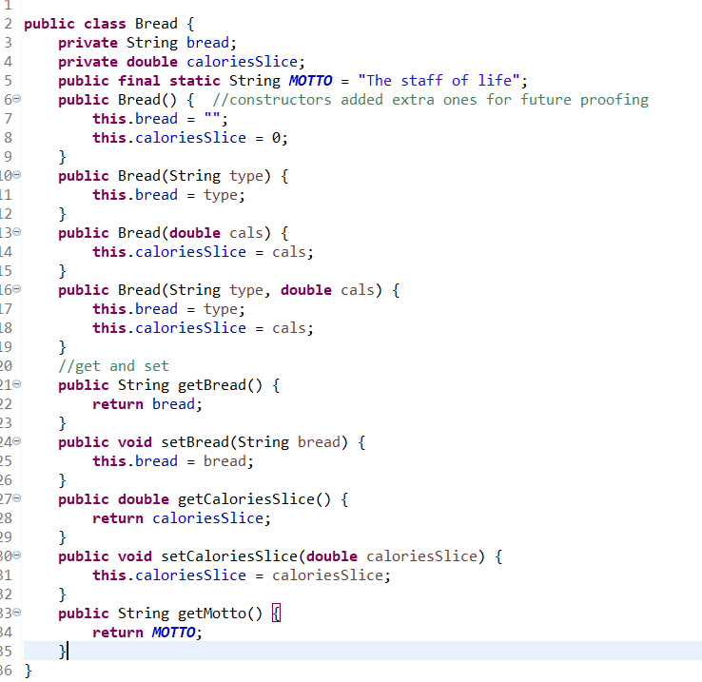

Sandwich Filling.java

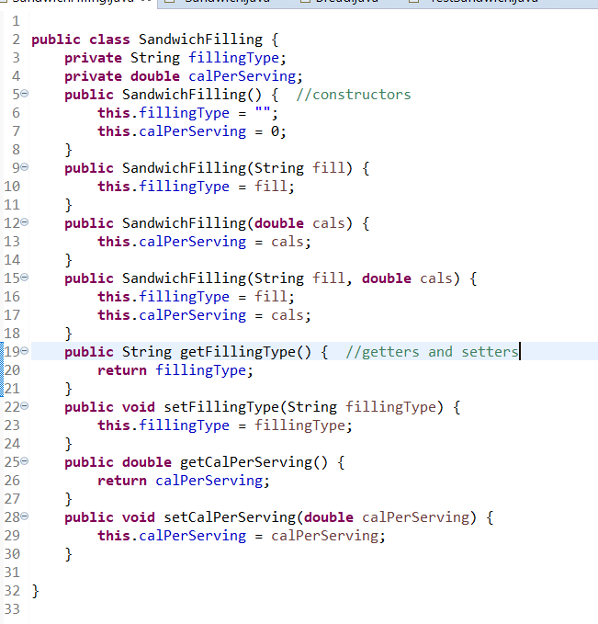

Sandwich.java

This was the hardest part. I’m still not use to making objects of objects. I had to rewatch the lecture videos to get this down. I wasted a lot of time doing it the wrong way.

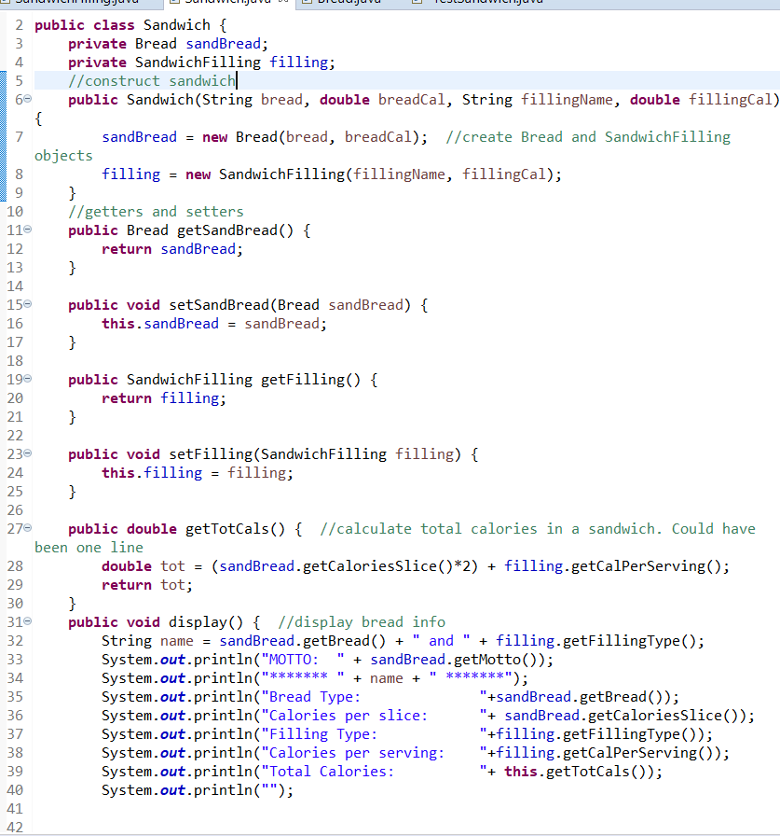

Main Program:

